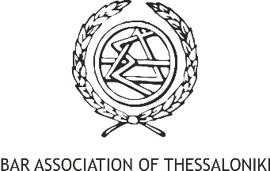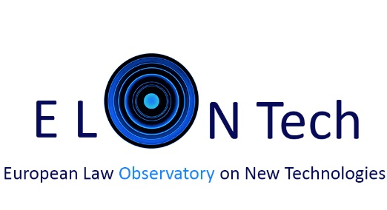

The 4th Industrial Revolution in Balkans: Law & Tech Summit
By European Law Observatory on New Technologies, in collaboration with the Bar Association of Thessaloniki and Centre for Research&Technology-Hellas- Information Technologies Institute (CERTH-ITI)
17th May 2019 | 9.30am-7.30pm | Venue CERTH, Thessaloniki
The 4th Industrial Revolution n Balkans, Law and Tech Summit by ELONTech: What are the Region’s opportunities and challenges, emerging from the advancement of disruptive technologies? How will policy-makers, law professionals and innovators of the Balkan economies adapt and respond?
Conference in English | Free-entrance | RSVP by 14th May here
https://www.eventbrite.com/e/the-4th-industrial-revolution-in-balkans-law-tech-summit-tickets-60751429160
During the 2018 Annual Meeting in Davos, a meeting of high level officials took place regarding the progress of the economies of the Balkans, by addressing the shared challenges they collectively face; boosting economic growth, improving infrastructure and the functioning of markets and attracting and retaining the talent they will need to thrive in the Fourth Industrial Revolution, between EU’s structural collaborations and Asia’s and U.S multilevel approach.
The European Law Observatory on New Technologies- ELONTech, the Bar Association of Thessaloniki and Centre for Research&Technology-Hellas- Information Technologies Institute (CERTH-ITI) invite the Law and Tech policy-makers, researchers, scientists and professionals from the Region to focus on a vivid discussion about the new technologies’ developments, the regulatory adaptation, the European regulatory process and best practices that can inspire and encourage further synergies.
THE AGENDA
9.30am-10.30am Arrivals-Registration at EKETA-CERTH
10.30-11.00 Introductory notes by ELONTech, Bar Association of Thessaloniki, & CERTH-ITI Representatives
Welcoming Speech:
Mantalena Kaili, co-Founder&Director ELONTech
Dr. Dimitrios Tzovaras, Director CERTH ITI-Centre for Research&Technology-Hellas- Information Technologies Institute
Efstathios Koutsochinas , Chairman Bar Association of Thessaloniki
11.00-16.00 PART I: The 4th Industrial Revolution, how did it start, where will it leads us?
Keynotes on Policy- Strategy-Infrastructure-Investments for 5G, AI, Blockchains
Opening Speech: Mariya Gabriel, EU Commissioner (tbc)

Keynote Speakers:
Martina Larking, World Economic Forum (tbc)
Eva Kaili, MEP, Chair of STOA Committee, European Parliament • ELONTech Advisor
Maria Boile, Head of Unit on Transport Economics and Environment, Maritime and Air Transport, at the Hellenic Institute of Transport (HIT), Centre for Research and Technology Hellas (CERTH), Prof. University of Piraeus • ELONTech Advisor
Petros Kavassalis, Associate Professor , Dpt of Financial and Management Engineering, University of Aegean • ELONTech Advisor
Konstantinos Votis, Dr & Researcher ,CERTH ITI- Information Technologies Institute
Panagiotis Demestichas, Prof. Dpt. Digital Systems, University of Piraeus
Elena Plexida, Government and IGOs Engagement Sr Director, ICANN, Brussels
Younis (O) Hijazi , YouScale Sàrl-S on Exponential Technologies, Luxembourg
On Yavin , CEO Cointelligence, London • ELONTech Advisor (tbc)
13.00-14.00 LUNCH BREAK
Antonios Broumas, EY, Platis - Anastassiadis & Associates Law Partnership • ELONTech Advisor
Alessandro Palombo, Founder Jur, Zug • ELONTech Advisor
Thibault Verbiest, Partner, DS Avocats, Fleurance Associes de Gaulle, Paris • ELONTech Advisor
Sima Baktas, Founder GlobalB Law Office, Istanbul • ELONTech Liaison
Ayca Aktolga, President of the Istanbul Bar Association Banking and Finance Commission, Istanbul
16.00-19.00 PART II Panels of Discussion New Technologies Basic Principles, Applications and Law issues for the professionals of the Region / Best Practices and Discussion / The Disruption and the Re-definition of Law, Regulation and Justice
Blockchain & DLT’s (Smart Contracts, Insurance, Real Estate, Logistics, Supply Chain, Energy , IP rights, Art), ICO’s risks and opportunities , IoT & AI developments – risks for Democracy

