SEMINAR
WHY DO EUROPEAN ELECTIONS MATTER?

Introduction  Georgios Dellios  Dean of the Law School  Aristotle University of Thessaloniki AUTH  Speaker  Donatella M. Viola  Editor and Main Author  of the Routledge Handbook of European Elections  Discussants  Theodoros Chadjipadelis  Department of Political Science AUTH  Akritas Kaidatzis  Law School AUTH  Lina Papadopoulou  Law School AUTH  Ioannis Papageorgiou  Department of Political Science AUTH  Ioannis D. Stefanidis  Law School AUTH  Moderator  Nafsika Gratsiou  Journalist |  | 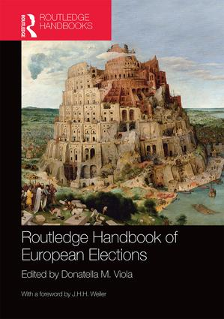
7 September 2016
18:30 – 20:30
Seminar Room 212
2nd floor Law School

