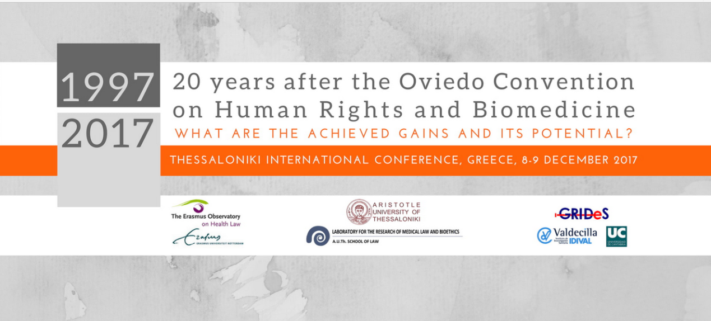
Thessaloniki InternationalConference20 years after Oviedo Convention on Human Rights and Biomedicine announces Christian Byk, John Harris, George Serghides and Rita Vassenna as Keynote Speakers, 8-9 December 2017.
Call for abstracts is now open for ThessalonikiInternational Conference to celebrate the 20th Anniversary (1997-2017) after signing the Oviedo Convention on Human Rights and Biomedicine of the Council of Europe.
The Conference will be hosted in Thessaloniki, Greece, at the premises ofMedical Chamber of Thessaloniki, jointly organisedby Laboratory for the Research of Medical Law and Bioethics (Aristotle University of Thessaloniki, School of Law) and Medical Chamber of Thessaloniki, as well asErasmus University of Rotterdam (Netherlands) andUniversity of Cantabria (Spain).
What are the achieved gains and the potential of the Treaty? International speakers of multiple disciplines will share their experience and expertise on a wide range of topics, featuring New Reproductive Technologies (NRTs), Embryo Research and Genome Editing, Organ Transplants and Equal Access to Health Care.
The Conference will attract attendees who will come together for 2 days of networking, professional development and personal growth opportunities.
To register or to learn more, explore our official conference site:
nicosia-conference2.webnode.es

