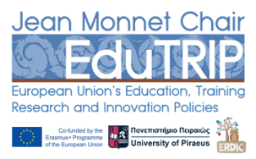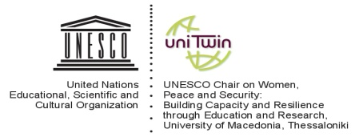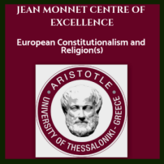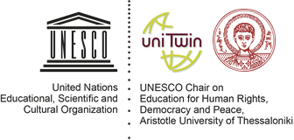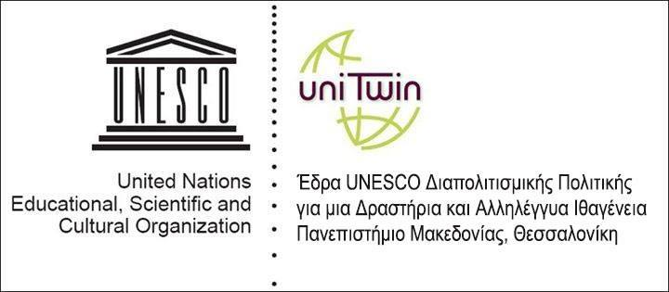

**In cooperation with:**

**Integration and Tolerance - Human Rights as a Guide**

**Culture, Diversity and Human Rights**

**Religious diversity and the Role of the State**

**Interculturalism - The Role of Intercultural Education and Intercultural Dialogue**

**INTERNATIONAL CONFERENCE**

**HUMAN RIGHTS AND CULTURAL DIVERSITY**

**26-27 November 2018**

**University of Macedonia,**

**Conference Room, University of Macedonia, 1st Floor**

**Egnatia 156, Thessaloniki**

**Certificates of attendance will be awarded**

**UNDER THE AUSPICES OF THE RESEARCH COMMITTEE OF THE UNIVERSITY OF MACEDONIA**